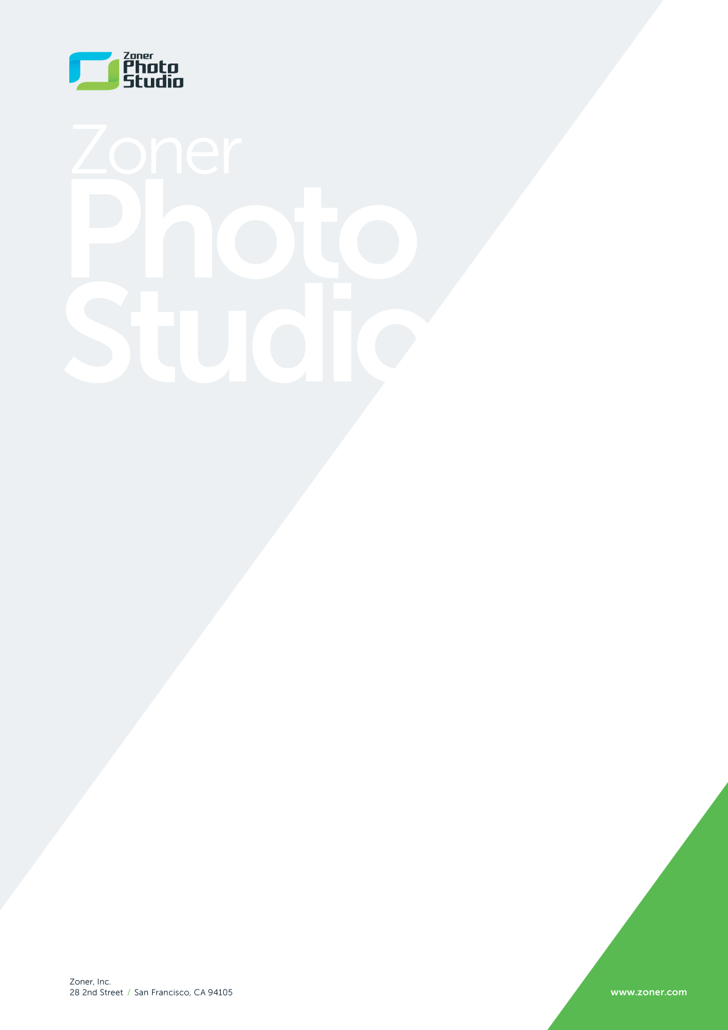
Zoner Announces the U.S. Release of Zoner Photo Studio 17
Award-Winning Program Gets Even Better. Provides Excellent Alternative to Lightroom.
San Francisco, September 29, 2014: Zoner, Inc., developers of Zoner Photo Studio image editing software and the free and unlimited Zonerama.com cloud service, has announced the official U.S. release of the new Zoner Photo Studio 17.
Already being referred to as an “excellent alternative to Lightroom,” Zoner’s latest version of this complete photo editing and management software package offers several exciting new features including Home Sharing, an easy and seamless way to share memories on your TV, PC and smartphone; the new and improved Cartoon and Lens Flare tools, a much more efficient photo management interface and more robust tools for working with RAW files.
“Our experience with past versions has taught us that users want a software program that offers them the opportunity to do everything from A to Z. That’s our ace in the hole with ZPS, that’s our foundation—it’s what separates us from all the pack,” explained Zoner’s Head of Development, Ales Hasala.
Most U.S. homes today own multiple computers, tablets and Smart TVs, so a feature like Home Sharing will have great appeal. The feature offers a fast and easy way to display and share photos on screens throughout the house, beyond the computer they are typically stored on. Show off pictures on your DLNA-compatible TV, Android devices that have Zoner’s Android app or any computer on your network.
For those that truly enjoy immersing themselves in the creative aspects of image editing, ZPS 17 has added a slew of new editing tools that will open up new directions to expand those talents. And for the more advanced users, ZPS 17’s Automatic Optical Defect Correction using LCP profiles will be a big hit as well.
Zoner has also made major changes to the program’s RAW module—the most significant since version 12. Zoner’s RAW development tool is now more powerful and intuitive than ever before. Among the improvements is a new Automatic button that streamlines working with the histogram and colors – one click now reveals the optimal settings. ZPS 17 also now reflects all changes in the RAW module in pictures’ previews in the Manager and Viewer. Working with large photo collections is now significantly faster and smoother in ZPS 17 courtesy of the program’s Smarter Catalog and an improved Side Panel in the Manager. Batch-tagging photos is now a snap using keywords and other metadata, both in the Manager and also during the photo Import process.
Zoner Photo Studio 17 is available now for just $89. Upgrades from older ZPS versions are priced at $49. Zoner also offers Household License extensions for $49.
The Windows download of the full version of Zoner Photo Studio 17, is available free for 30 days at www.zoner.com.
Zoner, Inc. develops and markets Zoner Photo Studio and also operates Zonerama.com, an unlimited and free photo cloud service. Zoner’s corporate offices are located in San Francisco, Tokyo, and the Czech Republic. The company launched back in 1993 by five fresh-faced, photography-loving graduates.
Contact:
Jaroslav Kucek
CEO
Zoner, Inc. | 28 2nd Street | San Francisco, CA 94105
e-mail: info@zoner.com| Twitter

